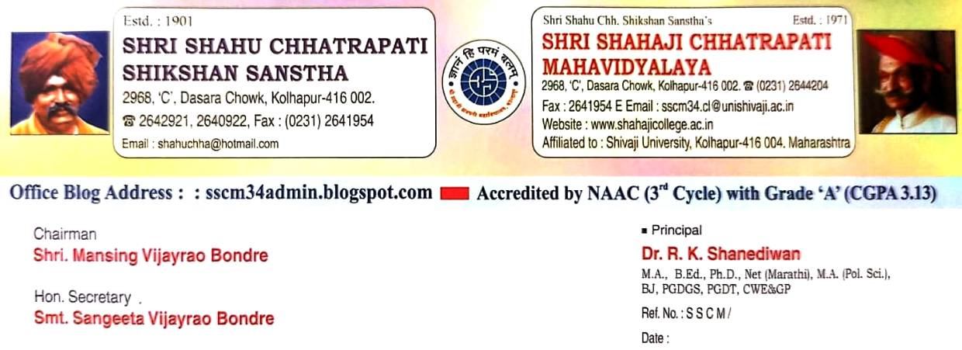

Report of the Programme 2024-2025
Tribute Program for Rajmata Jijabai and Swami Vivekananda
1) Time : 8.00 to 11.00
2) Day and Date : 11 January 2025
3) Objectives of the Programme :
1) To introduce the biography of Maharani Jijabai.
2) To introduce the biography of Swami Vivekananda.
4) Outcomes of the Programme :
3) Understood the biography and work of Maharani Jijabai.
4) Understood the biography and work of Swami Vivekananda.
5) Brief Summary of the Programme:
On January 11, 2025, the History, NSS, Geography Departments, and IQAC organized a tribute program for Rajmata Jijabai and Swami Vivekananda, along with the "Reading Pledge Maharashtra" initiative. Over 370 students participated. The event featured floral tributes, guest lectures by Dr. Pallavi Kodak and Dr. Poonam Bhuyekar, and a collective reading of Swami Vivekananda’s teachings. Principal Dr. R. K. Shanediwan emphasized their enduring inspiration. The program successfully promoted historical awareness and a strong reading culture.

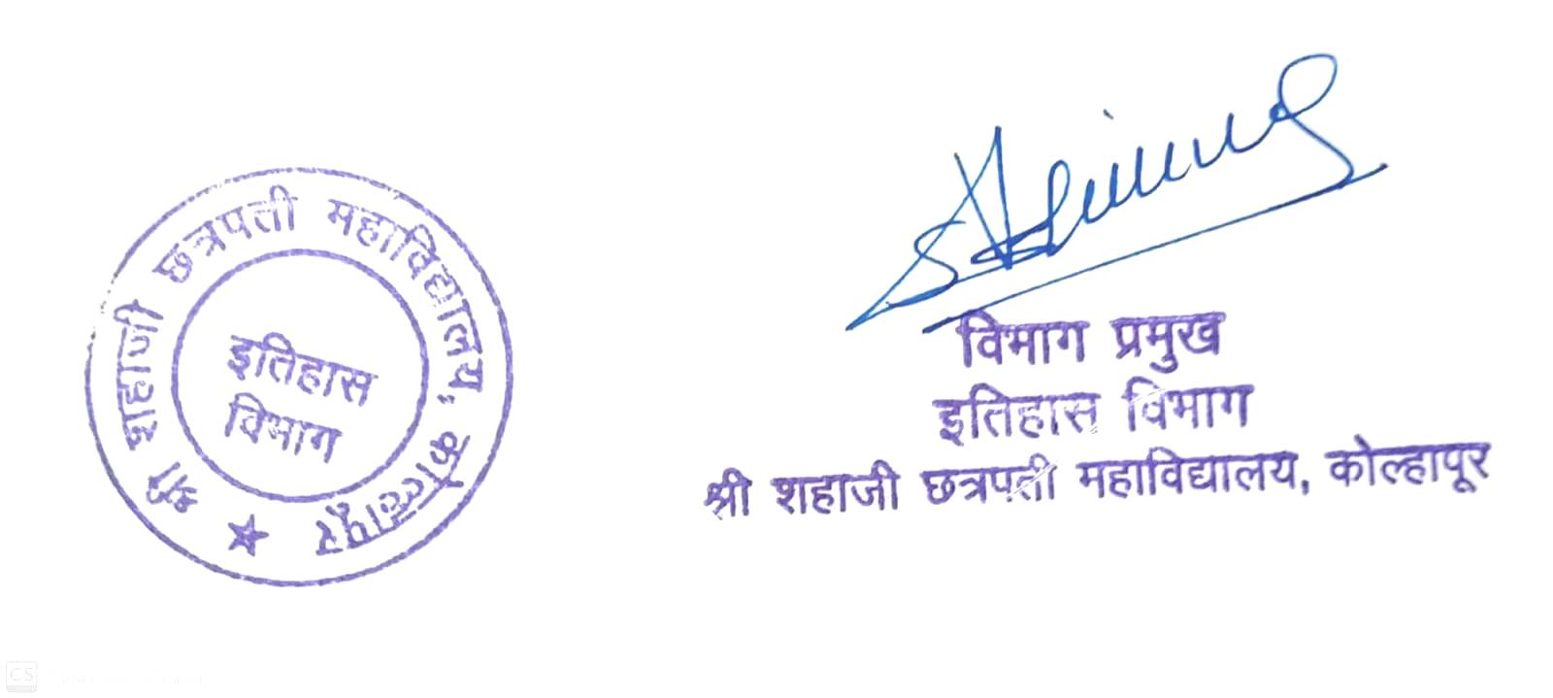

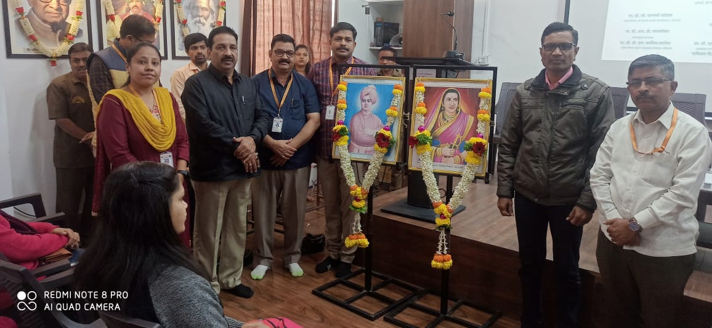
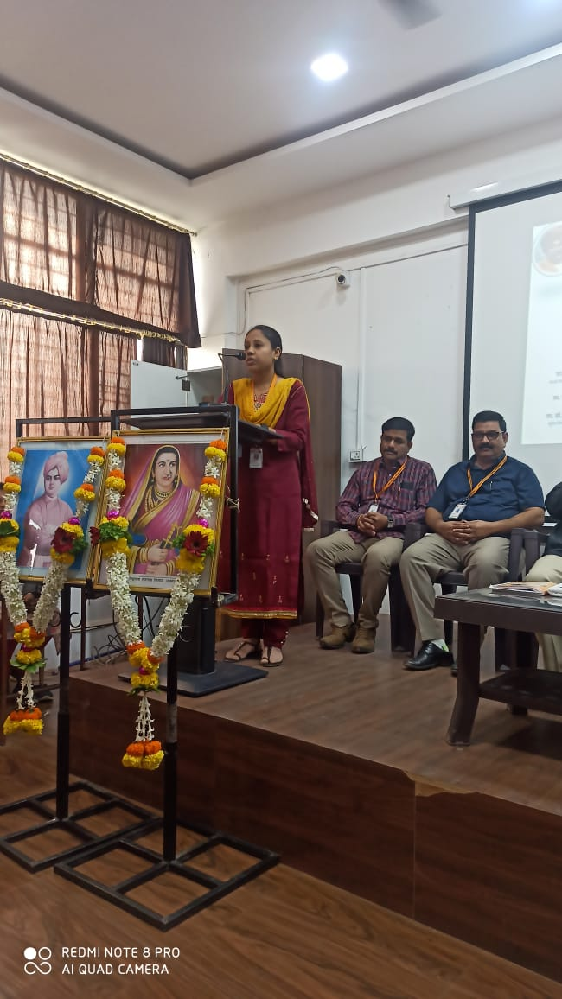
Dr. Pallavi Kodak delivered a lecture on the life and work of Rajmata Jijabai.
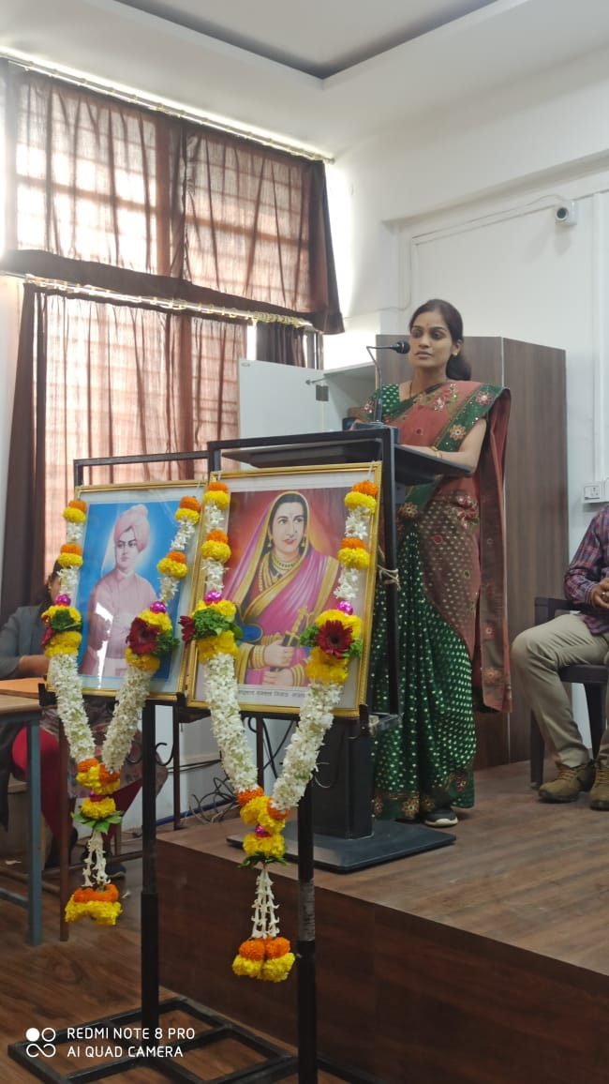
Dr. Poonam Bhuyekar delivered a lecture on the life and work of Rajmata Jijabai.
